**What are the advanced and cutting-edge technologies (e.g., artificially intelligent technologies) being used for Indian retail?**

**Introduction**

Today, the retail business in India is responsible for more than 10 percent of the nation's gross domestic product and about 8 percent of the employment in the country.

Research by Bain & Company in collaboration with Flipkart titled "How India Shops Online 2021" predicts that the e-retail industry will grow to US$120-140 billion by FY26, expanding at an estimated rate of 25-30% p.a. during the following five years.[2]

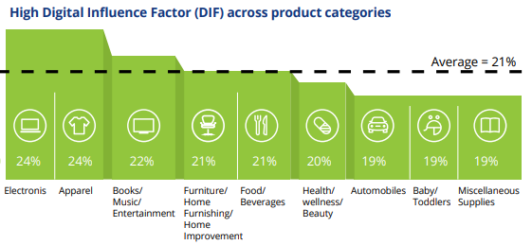

Retailers are turning to data and digitalization to handle challenging consumer behavior shifts as recession worries swirl. E-commerce is becoming the platform of choice for many people who have never shopped online. The digital retail transformation is well underway. Major firms in the retail sector have been embracing modern-age, cutting-edge technologies like Artificial Intelligence (AI), Machine Learning (ML), chatbots, and smart search software to redesign customers' purchase experience.

**AI – Artificial Intelligence**

59% of consumers believe that AI-driven product data influences their purchasing decisions, whereas the majority of companies believe that user experience is more important for online sales and conversions. AI may analyze customer behavior to recommend suitable products and services. According to research by [Tractica](https://omdia.tech.informa.com/), global AI revenues will grow from $643.7 million in 2016 to an excess of $36.8 billion in 2025.

**Chatbots**

Chatbots have sped up consumer-online retailer contact by providing timely information and being widely accessible. Support is always accessible, and questions are answered immediately. These chatbots use AI and machine learning to engage users, answer questions, and assist them. The bots collect a lot of client data, which may be used to improve the company's operations. Machine learning and deep learning techniques like a decision tree are used in chatbots to automate complicated business processes. By 2023, chatbots will be responsible for more than $100 billion in online sales.[6]

More than any other sector, 34% of online retail shop consumers embrace AI chatbots.

For example, the adoption of AI chatbots among banking clients remains at only 20%, and in the insurance business, that number is 15%.[5]

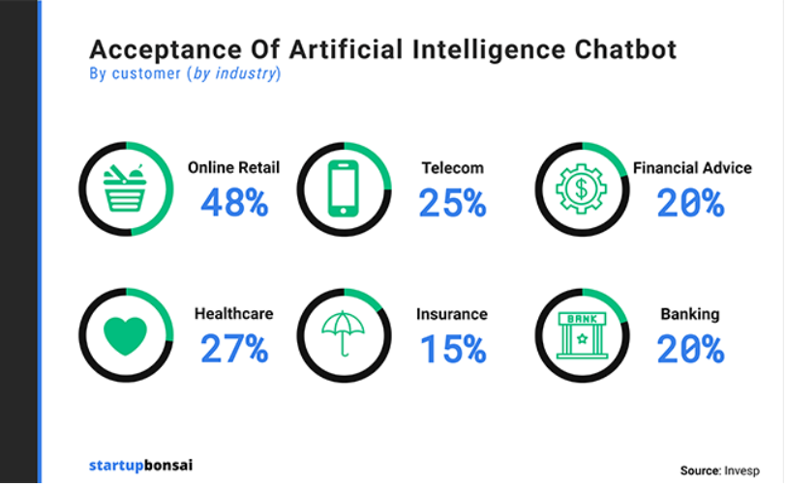

**Smart search**

Intelligent search is an essential component of advanced online shopping since it optimizes searches inside the virtual store. As an expanded application of artificial intelligence, intelligent search capabilities include sophisticated qualities such as rapid speed, Autosuggestion, phonetic similarity, 100 percent automatic color search, behavioral search personalized for each client, voice search, and so on. The use of technology enhances the consumer's purchasing experience, increases conversion rates, and influences customer loyalty. In an examination of 22 different websites, users were 1.9 times more likely to convert when they searched for a product. In addition, prospective clients utilizing search may generate up to 13.8% of a website's total income.[8]

**Cashier-less Stores**

Contactless services are popular. Due to the epidemic, customers choose enterprises without cashiers. Businesses that minimize queues attract customers, particularly health-conscious ones. These stores can automatically scan things and accept card payments. Using technology, retail workers can ensure customer flow. It may lower merchants' operating costs. This strategy is gaining favor in business to improve efficiency and profitability. Omnico observed that consumers detest waiting to pay (52%) and lineups (49%); autonomous checkout might eliminate both. Nearly three-quarters of US respondents say technology will make shopping more uncomplicated and open to cashierless establishments.

**QR Codes**

The QR code is one of science's best ideas and has helped many industries. The code cuts costs for the owner and makes customers happier. Booklets are expensive, and store owners don't need them. QR codes carry product details. When customers scan the code, they can find out about the product. Customers can interact with these codes through video, text, PDF, coupons, and more. The codes can also be used to tell people the website's URL, which can increase traffic and sales. More than 9 million stores in India accept payments with QR codes. (Mobile Transaction). In June 2021, 2.8 billion transactions worth INR 5 trillion were made through the UPI interface, an integrated payment system that lets people pay their banks with QR codes. By 2027, the market for QR code labels is anticipated to reach $2.1 billion, expanding at a CAGR of 8.9%.

**Buy Online. Pick Up In-store (BOPIS)**

It has evolved as a simple and economical alternative where a customer can purchase the goods online and pick them up from the store. It is the ideal combination of online and in-store purchasing. Consumers may choose things at their convenience and pick them up from the shop when instructed. It saves the money charged for delivery, besides providing same-day pick-up options. About 67% of consumers in the US have utilized Buy Online Pick Up In Store (BOPIS). 38% of retailers observed that BOPIS was key to bringing shoppers into the store. 77% of customers prefer it as it allows them to see products before taking them home. It helps the retailers to keep up with competitors and Attract shoppers who make additional purchases.[7]

**Internet of Things (IoT)**

The IoT enables instantaneous connectivity by connecting billions of devices for constant data exchange. Every day, retailers create a deluge of data that may be used to learn important insights about shoppers' habits and preferences. Because of IoT, this industry can effortlessly gather, store, and analyze these statistics. With this knowledge, businesses may provide customers individualized service by meeting their specific requirements. It may also aid the industry in attracting customers. The store's employees may coordinate their efforts to provide superior customer service using wireless gadgets built on the Internet of Things. [9]

The size of the worldwide market for the Internet of Things (IoT) in retail is projected to increase from USD 14.5 billion in 2020 to USD 35.5 billion in 2025 at a Compound Annual Growth Rate (CAGR) of 19.6% over the forecast period. Due to the customer's need for a smooth shopping experience and the rising popularity of innovative payment systems, the market is growing. IoT sensors and hardware are rapidly decreasing in price.

**What are the common organizational strategic approaches?**

**Customer experience**

Using digital for in-store processes, merchandising, marketing, and promotions improves the customer experience. The digital customer journey covers the whole lifecycle, from finding out about a business to staying loyal to it. It is getting more and more complicated. In the current market, companies use bots to help customers decide what to buy and real-time, dynamic, competitive pricing for customers. Augmented reality (AR) and virtual reality (VR) are used to help try out products and make shopping more fun.

Van Heusen opened a ready-to-wear experience store in Bengaluru. The iPads in the fitting rooms let customers choose the clothes they want to try on and choose the size they want.

**Digital Supply Chain**

In conventional supply chains, each stage depends on the one before it. Develop, plan, source, create, deliver, and support. Each supply node lacks transparency, which may lead to inefficiencies. As each supply node becomes more competent and networked, the supply chain collapses into a digital supply network (DSN). Always-on agility, linked community, intelligent optimization, end-to-end transparency, and holistic decision-making are DSN characteristics. Walmart deployed Universal Product Code bar codes, which gathered and analyzed store-level data. The corporation subsequently created Retail Link, a massive database. Retail Link connects analysts who predict supplier demand to the supplier network, which shows real-time sales data from cash registers and Walmart's distribution locations.

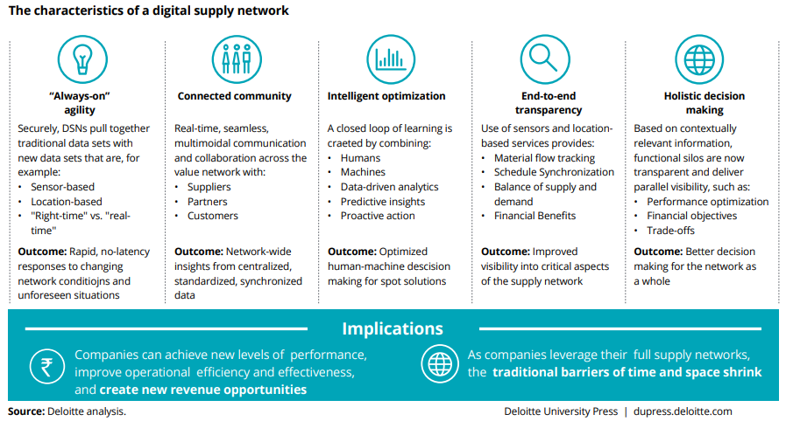

**Payment**

Recent advancements in financial transaction technology have increased the usage of electronic-based payment instruments internationally. In sophisticated nations such as the United States, France, etc., the use of cash for consumer products has fallen since 1980. Electronic payments have made significant gains among consumers in these nations accounting for ~ 60% of all consumer transactions. Instead of traditional payment terminals, Indian shops may use self-checkout solutions connected with digital wallets like Aadhaar Pay / UPI. Initiatives such as Samsung Pay or Apple pay which are integrated with client cellphones, may also be tapped for speedier payment. The National Payments Corporation of India (NPCI) created the card payment program to provide a domestic, open-loop, multilateral system enabling all Indian banks and financial institutions to engage in electronic payments.ePaisa, Paytm, and the likes also play an essential role in the convenience of customer payments.

**Endnotes**

1. Digital influence factor is the % of in-store retail sales influenced by a shopper's use of any digital device(laptops, desktops, smartphones, tablets, wearables) and in-store devices (i.e., mobile payment devices)
2. <https://www.ibef.org/industry/retail-india#>
3. <https://www.e-zigurat.com/innovation-school/blog/companies-digital-transformation-strategies/>
4. <https://www.indianretailer.com/article/technology/digital-trends/9-tech-trends-reshaping-the-retail-industry.a7896>
5. <https://www2.deloitte.com/content/dam/Deloitte/in/Documents/CIP/in-cip-disruptions-in-retail-noexp.pdf>
6. <https://www.servicebell.com/post/chatbot-statistics#:~:text=Key%20Chatbot%20Statistics&text=23%25%20of%20customer%20service%20companies,highest%20rates%20of%20chatbot%20acceptance>.
7. <https://www.invespcro.com/blog/buy-online-pick-up-in-store-bopis/>
8. <https://itooze.com/blog/smart-search-for-ecommerce/>
9. <https://www.marketsandmarkets.com/Market-Reports/retail-iot-market-43188550.html>